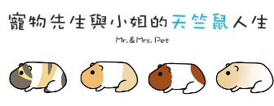

貼心小叮嚀：定期定額的追蹤觀察天竺鼠們的體重，一來可以看他們是否發育正常，二來若有異常變化或長期下降趨勢可以讓我們即早發現並帶去醫治。

照片

性別

生日

品種

主人姓名

__________的體重紀錄表

|  |  |  |  |  |
| --- | --- | --- | --- | --- |
| 測量日期 | 體重 | 增減值 | 是否剪指甲 | 其他備註 |
|  |  |  |  |  |
|  |  |  |  |  |
|  |  |  |  |  |
|  |  |  |  |  |
|  |  |  |  |  |
|  |  |  |  |  |
|  |  |  |  |  |
|  |  |  |  |  |
|  |  |  |  |  |
|  |  |  |  |  |
|  |  |  |  |  |
|  |  |  |  |  |
|  |  |  |  |  |
|  |  |  |  |  |
|  |  |  |  |  |
|  |  |  |  |  |
|  |  |  |  |  |
|  |  |  |  |  |
|  |  |  |  |  |
|  |  |  |  |  |
|  |  |  |  |  |
|  |  |  |  |  |
|  |  |  |  |  |
|  |  |  |  |  |